Green Meadow Tech, New York
山东善诺惠众生物科技有限公司
生物及纳米科技产品介绍
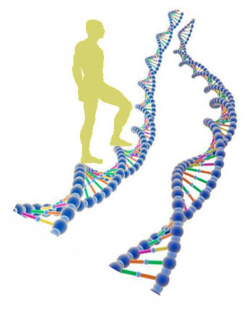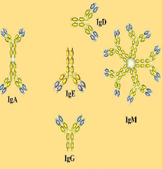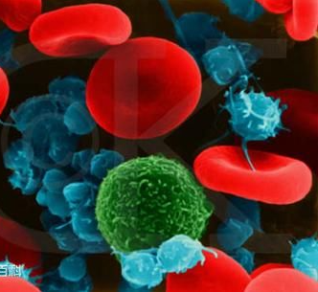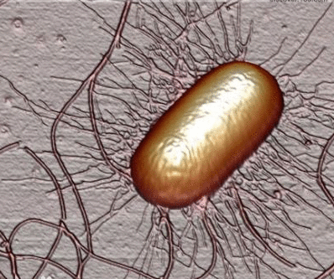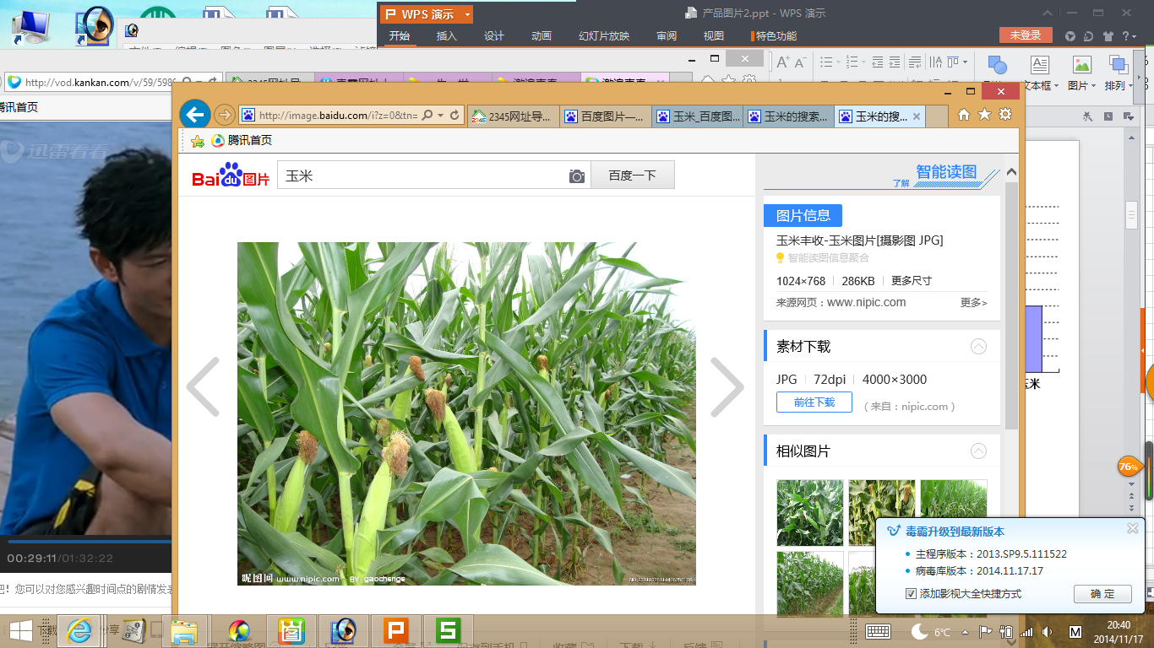

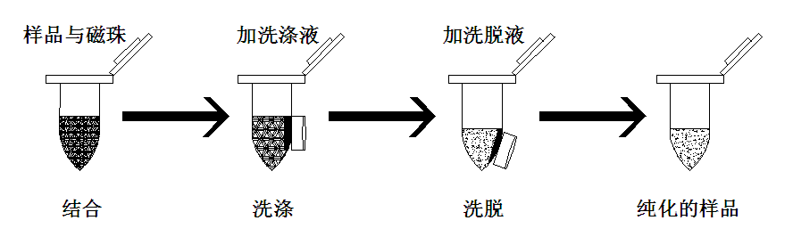

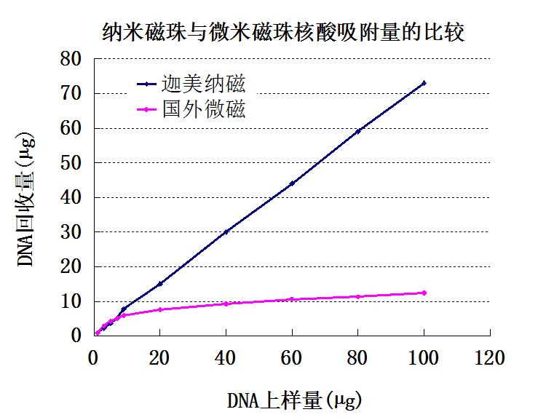

山东善诺惠众生物科技有限公司产品目录
第一章GMT纳米磁珠法生物样品制备系列 ..................... 1~
NanoMag™ 纳米磁珠法核酸提取与纯化
- 通用型生物基因组DNA提取试剂盒....................................................................
- 通用型生物总RNA提取试剂盒 ..........................................................................
- 植物(树木蔬菜农作物)基因组DNA提取试剂盒 .....................................
- 植物RNA快速提取试剂盒 ........................................................................
- 人及动物全血基因组DNA提取试剂盒 ...................................................
- 人及动物基因组DNA提取试剂盒.................................................
- 人及动物RNA提取试剂盒.............................................................
- 细菌基因组DNA提取试剂盒 ...................................................................
- 细菌RNA快速提取试剂盒 .................................................. ....................
- 真菌基因组DNA提取试剂盒 ...................................................................
- 真菌RNA快速提取试剂盒 .................................................. ....................
- 土壤DNA提取试剂盒
- 土壤总RNA提取试剂盒
- 质粒DNA提取试剂盒 ................................................................................
- 去内毒素质粒DNA提取试剂盒 ................................................................
- 凝胶DNA回收试剂盒 .................................................................................
- DNA纯化试剂盒 .............................................................................................

第二章GMT多功能纳米磁珠系列.................................... 2~
- 无修饰纳米磁珠 ...........................................................................................
- 羧基纳米磁珠 ...............................................................................................
- 磺酸基纳米磁珠 ...........................................................................................
- 氨基纳米磁珠 ...............................................................................................
- 酸酐基纳米磁珠 .........................................................................................

第三章GMT磁分离器系列 ............................................ 3~
- 微型离心管磁力分离架 .............................................................................
- 大型离心管磁力分离架 .............................................................................
- 96孔板磁力分离器 ....................................................................................

